UML class diagram

|  |
| --- |
| btn.h |
| Btn(); |
|  |

|  |
| --- |
| drum.h |
| drum() , void *advance*(int phase); |
| int speed |

|  |
| --- |
| mainwindow.h |
| void settingBg(); void settingBtn_start(); void settingBtn_exit(); |
|  |

|  |
| --- |
| rail.h |
| Rail(); |
|  |

|  |
| --- |
| scene.h |
| void Init();  void bgChange();  void bgRecover();  void *mousePressEvent*(QGraphicsSceneMouseEvent *event); |
| int dis = 0;  Btn *btn_start;  Btn *btn_exit;  Btn *btn_back;  int btn_start_w;  int btn_start_h;  int btn_exit_w;  int btn_exit_h;  int btn_back_w;  int btn_back_h;  int dis = 0;  Btn *btn_start;  Btn *btn_exit;  Btn *btn_back;  int btn_start_w;  int btn_start_h;  int btn_exit_w;  int btn_exit_h;  int btn_back_w;  int btn_back_h; |

Screen shot:

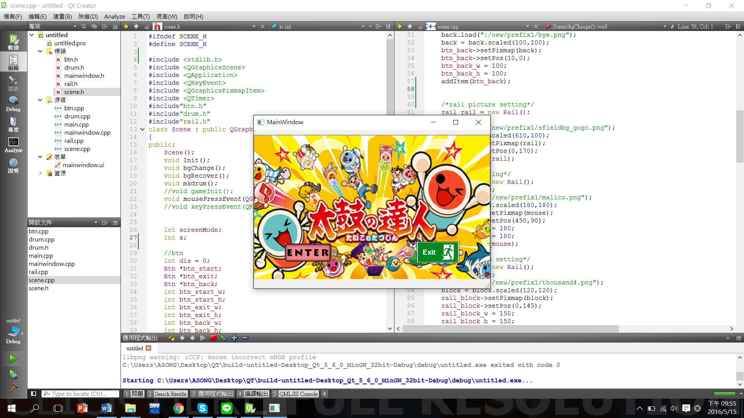

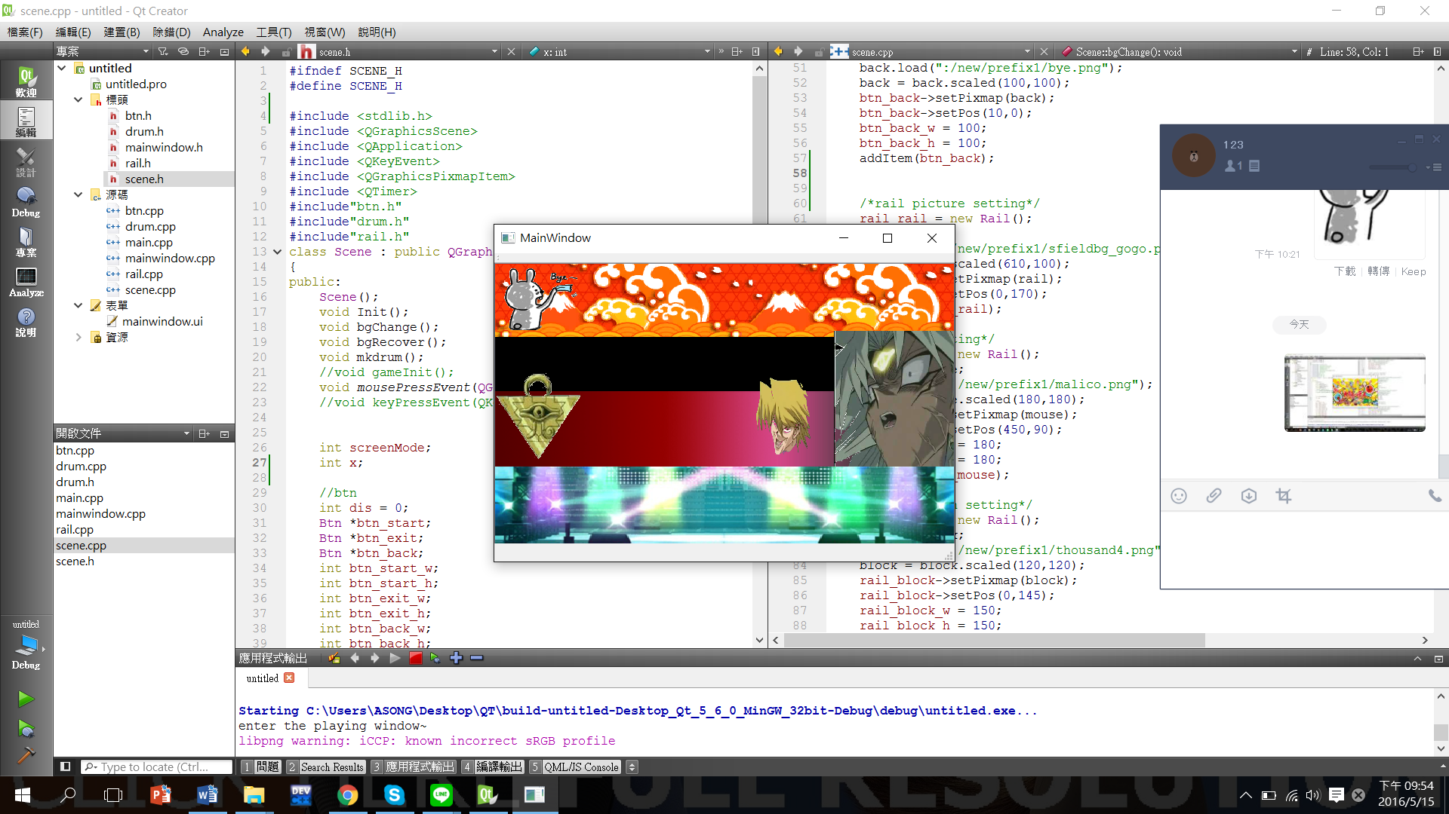

How to play

Use the enter button then you can enter the playing scene . And if you want to shut down the program, you can press the exit button. If you want to return the mainwindow when you are in the playing scene, you can press the bye button as the rabbit on the upper left. And you can return to the mainwindow. I don’t finish the part of score,time and playable because I use the wrong way at first. I am so sorry.

Program architecture

The class btn:

Using this class, I can form three button enter,exit and back. With the function mousePressEvent, we can give these buttons its useful feature. Like entering the playing scene,exiting the program or returning the mainwindow. And in the mousePressEvent function ,we can set the range that when the mouse press on it ,it can use the feature we give it.

The class drum:

In this class, we can form a random drum on the rail. I use the rand() and if loop. If x=0 , form a drum-a. And if x=1 , form a drum-b.

The mainwindow :

It can put all the object on this window , the background,the drum,the button…..

The scene class :

It is the biggest part of my code .Include Init(), bgChange( ), bgRecover() , and mousePressEvent(). In the Init(), I load my start button and exit button and then set their position and size . In the bgChange(), I load the playing background and then remove the start button and exit button . And I add and set the position and size of the back button , my rail , startline,endline and the my drum.

In the bgRecover(), I give my back button function. When I push the back button, I can return the start window and remove the object in the playing window.